**41012 CONCERNS**

Student Number: 22121150

Concern: No schedule yet.

Student Number: 22013354

Concern: No schedule yet.

Student Number: 22120724

Concern: No schedule yet.

Student number: 22013919

Concern: Wrong section, dapat po 41012 (cluster 12 po ako) ang nakalagay sa cap, ojt, ite4.

SS ng Cor:

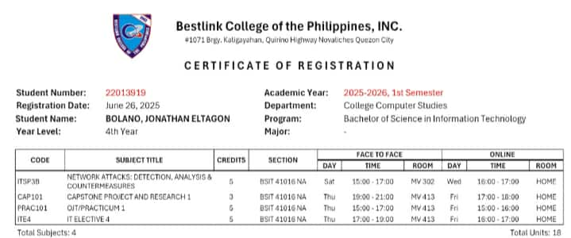

Student number: 22122716

Concern: No schedule yet.

Student number: 22120633

Concern: No schedule yet.